The Texas Top Ten Percent Plan: Its Context and Effects on Inequality

Erica Kilbride

MA Candidate in Quantitative Methods in Social Sciences

SOCIG 4370

08

**Fall**

**Introduction**

In the latter half of the 20th century, several universities looked to reverse a long history of systematic discrimination by increasing representation of minorities in their student body. This required a modification of existing admissions processes to provide advantages to minority applicants not available to the majority applicants. Attempts to reverse the admission inequality continue today. These methods are highly controversial and far from perfect.

This paper begins with a brief history of affirmative action in college admissions and legal cases that affected its use. It examines results of removing race from admissions in university enrollments and the importance of these results in an economic context. Texas’s Top Ten Percent Plan is introduced and compared to other states’ percent plans. The landscape in which the plan takes place is described in two portions to underscore both the scale of the plan’s potential impact and the reasons for its success. A review of studies examining the effects felt after the plan’s enactment follows. Finally, the Supreme Court case currently being heard regarding the University of Texas’s admission policies is briefly discussed.

**Affirmative Action and Ensuing Lawsuits**

Put into place by Executive Order 10925 in 1961, affirmative action was specifically directed at government employers but its influence quickly spread to other sectors. Race-based policies soon were adopted in housing, private employment, and tertiary education admission decisions with the intent of ensuring representation of minorities. The policies in tertiary education admissions generally fell into two methods: quotas or full-file reviews in which the candidates’ full qualifications (or “files”) are considered along with race.

Over ten years after its implementation, the use of affirmative action in university and college admissions came under its first legal review in *Regents of the University of California v Bakke*. The Supreme Court used the Fourteenth Amendment’s Equal Protection Clause as the basis for its consideration of the dual admission practice at the Medical School at the University of California at Davis. The Equal Protection Clause states that racial discrimination is prohibited except where there is a compelling state interest and narrowly tailored means (Regents of the University of California v. Bakke, 1978). The court ruled in *Bakke* that specific quotas failed to meet the strict requirement of narrowly tailored means, though Justice Powell, author of the majority opinion, agreed race should be used in admission policies and that the state has “ a legitimate… interest in ameliorating…the disabling effects of identified discrimination” (Regents of the University of California v. Bakke, 1978).

Decades after *Bakke*, a trio of lawsuits concerning the affirmative action policies for both law schools and undergraduate admissions were heard. The 1996 *Hopwood v Texas* decision ruled that law schools could not use race at all in their admission decisions, citing a violation of the Fourteenth Amendment (Hopwood v. University of Texas ). Prior to this ruling, black and Hispanic students with lower overall GPAs and LSAT scores were granted admission at higher rates than white applicants with higher scores. These admissions policies also created a “discretionary zone” of further review for applicants not immediately admitted or denied. In this discretionary zone, black and Hispanic applicants were examined with less scrutiny and granted admission at a higher rate with lower scores than whites and “non-preferred minorities” (Davis, 2013). It is important to note that this decision was reached in the 5th Circuit court, not the Supreme Court, so this ban on using race in admissions decisions was applied to the 5th Circuit’s jurisdiction.

In contrast, the 2003 Supreme Court rulings on two affirmative action cases at the University of Michigan had nationwide impact. The *Grutter v Bollinger* decision reaffirmed their *Bakke* findings, stating, "student body diversity is a compelling state interest that can justify the use of race in university admissions" (Grutter v. Bollinger, 2003). Though quotas were still ruled out, the court promoted race-based admissions programs that had flexibility to “consider all… elements of diversity… of each applicant and to place them on equal footing… although not necessarily giving them the same weight” (Grutter v. Bollinger, 2003). The Michigan Law School application was found to have achieved this flexibility and the Court ruled it satisfactorily tailored. That same day, *Gratz v Bollinger*, a case concerning undergraduate admissions at the University of Michigan, was heard by the court. This admission policy included an index of points granted to each applicant and a miscellaneous category automatically allocated points to underrepresented minorities. The court found that the allocation of these points were not narrowly tailored and cited a lack of individualized reviews that was previously found in *Bakke* and *Grutter*. In short, the ban on use of quotas was upheld, and the use of race as a factor in admissions was upheld, as long as it was not the determinant of admissions.

**What Happens When AA is Removed?**

The ban of affirmative action in admissions policies was not instituted nation-wide, but through the jurisdiction of district courts or state ballot propositions, generating some interesting results. Studies confirmed the fear that removing affirmative action policies would reduce the probabilities of admission for minority students, though these reduced probabilities are limited to selective schools. At public universities in the top 50 of the U.S. News & World Report ranking, a ban on affirmative action policies led to a decrease in the number of black and Hispanic students (30% and 27 %, respectively) and led to an increase in white and Asian students (5% and 6%) (Hinrichs, 2012). While the number of black and Hispanic students at selective institutions dropped when affirmative action was banned, overall black enrollment at universities was stable (Backes, 2012). This suggests a downward cascade effect, with more minorities enrolling at less-selective institutions.

**Economic Impacts of Selective Post-Secondary Graduation**

Admission to a selective university is highly competitive, and for good reason: graduating from these universities provides opportunities that may otherwise not be available. Studies show white males students who just met admissions criteria at flagship universities generally earn 20% more than students who just fell short of meeting the criteria (Hoekstra, 2009). The figure below shows the discontinuity in log earnings of these students:

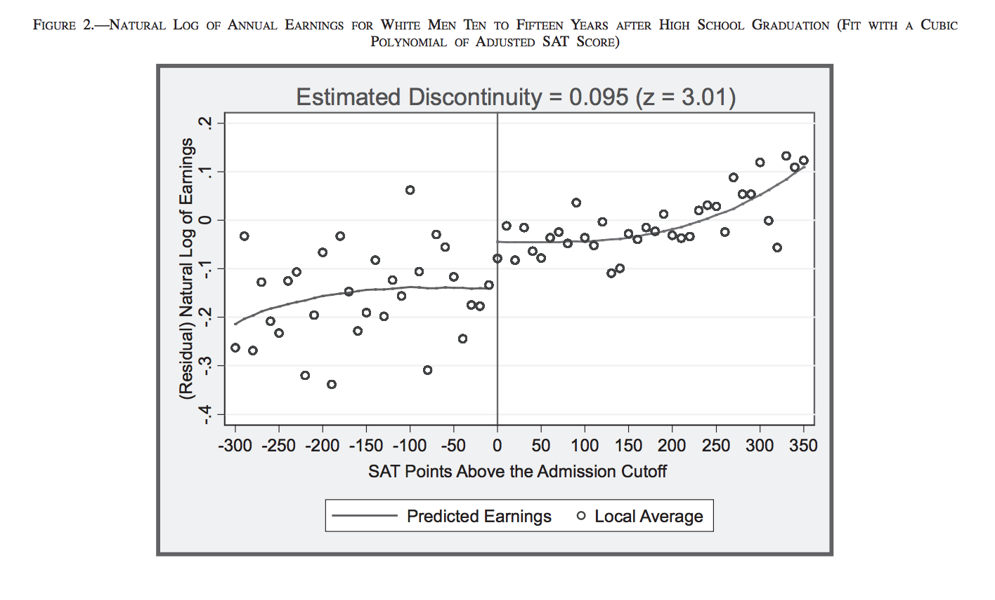

(Hoekstra, 2009)

Black and Hispanic students, as well as those from disadvantaged backgrounds, receive the greatest return from selective college graduation. A study of a 1989 cohort at a highly selective college suggests greater earnings returns for students whose parents had an average of less than 16 years of schooling than those with more educated parents. The earnings return of attending a more selective school for students from more educated families was negligible and, at times, even negative. The authors of this study suggest this is driven by a difference in networking connections: students with educated parents may be able to rely on their families or friends for job-networking opportunities while less advantaged students do not have the same inherited network. Therefore, the networking opportunities that are made available in attending a selective school are especially valuable for black and Hispanic students, as well as student from less educated families (Dale & Krueger, 2011).

While these earnings premiums affect the graduates directly, it can provide social value for communities as well. A study of a 1976 cohort of selective schools found beneficiaries of affirmative action are more likely to participate in community, social service, youth, and educational organizations in their community (Long, 2007).

**What is the Top Ten Percent Plan?**

For two years after the *Hopwood* decision, the admissions policies at Texas state higher education institutions had no consideration for race at all. In this two-year period, first time freshman enrollment for blacks and Hispanics dropped drastically while enrollment for whites and Asians increased.

In 1998, as a response to the *Hopwood* decision but prior to the *Grantz* and *Gullinger* cases, the State of Texas legislature passed House Bill 588, requiring state-supported tertiary education institutions to admit any graduate in the top ten percent of his or her Texas high school (public or private) to the state-funded school of his or her choice. The designation of top decile standing is determined at the end of the junior year in high school, beginning of the senior year, or at high school graduation; whichever is most recent at the time of the college application deadline (Cullen, Long, & Reback, 2013). This bill was known commonly as the “Top Ten Percent Rule” or “Top Ten Percent Plan” (TTPP) and was accompanied with a suggested list of 18 criteria to use in admissions decisions. These criteria were intended to give favorable consideration to applicants with disadvantaged social and economic backgrounds. The aim of the Top Ten Percent Plan was to regain the diversity lost after the Affirmative Action ban through race-neutral policies.

Just as the removal of affirmative action happened in other states, approaches to compensate for the removal were implemented in these states as well. While percent plans were implemented in Florida and California, they are not direct equivalents to the TTPP (Flores & Horn, 2015). The TTPP allows admission into any state-funded school of the applicant’s choosing; the Californian Eligibility in Local Context Plan (ELP) grants access to a school within the University of California system, though not necessarily of the applicant’s choice. The TTPP considers both public and private high schools; Florida’s Talented 20 program grants admission to the top 20% of public high schools only. Texas high schools have a significant amount of autonomy in determining class rank distribution, including weighting honors or courses taken for college credit; California has a uniform method of determining class rank and is administered by the UC system (Niu & Tienda, 2010). To address concerns of students taking less rigorous courses to boost their GPA, in 2001 the Texas legislature passed an amendment requiring TTPP applicants to complete a recommended or advanced curriculum if it is offered at their school; only GPA for college preparatory courses is considered for ELP class ranking (Geiser & Santelices, 2007) (Niu & Tienda, 2010).

**Texas Demography**

When reviewing attempts to increase diversity at Texas post-secondary institutions, it is important to consider both the demographics and growth rates in the state. In 2000, over 40% of the state population was non-white (Center for Health Statistics - Census 2010). During the next ten years, Texas had the largest population increase, numerically, of all states; it also registered the second and third largest number of Hispanics and black, respectively, during this time period. This population growth is due to three factors: high natural increase (birth rates exceeding death rates), international migration, and internal migration. The combination of these factors led to Texas’s relatively young population. Additionally, the birth rates of black and Hispanic minorities were higher than whites, so population projections for these groups were higher as well (Leicht & Sullivan, 2000). In 2010, the state had the largest black and Hispanic 4-year undergraduate populations in the nation (Flores & Horn, 2015). Since admission to selective post-secondary institutions is a scarce resource, the demographics of Texas contribute to the complex puzzle of competition and equality.

**Why TTPP Could Work in Texas**

Why would accepting the top 10% of students from high schools statewide increase the amount of diversity on campuses? How could this measure ensure black and Hispanic acceptance without considering race in admissions? In a perfect world, students would be randomly distributed across Texas high schools with each race’s representation proportional with statewide distribution, and with equal probability of placing in the top decile. In this case, the TTPP would be successful in admitting a representative sample of the Texas student population. In reality, the success of TTPP hinges on the segregation of Texas high schools.

Entropy indexes indicate the overall degree to which blacks, whites, Hispanics, and Asians are separated from each other. The state of Texas’s entropy index of .33 qualifies it as a state with high levels of segregated secondary school education; the within-county component of the index score is .15 (45%) while the between-county component is .18 (55%) (Tienda & Niu, Capitalizing on Segregation, Pretending Neutrality: College Admissions and the Texas Top 10% Law, 2006). Only one in four high school seniors of Texas attend integrated schools; over 40% attend schools with extreme segregation. It is interesting to note that this segregation does not merely follow the narrative of “white flight” (white suburban schools and minority urban schools) since 47% of suburban Texas schools are majority black and Hispanic.

The table below shows the distribution of Texas public high school seniors in 2002. Panel A shows the total distribution by race across high school types while panel B shows the distribution of the top decile by race across high school types. As the authors of the study explain, the difference between these panels, reported in panel C, shows the extent to which segregation either increases or decreases a group’s chances of graduating in the top decile of their class relative to the assumption of uniform probabilities based on their population shares.

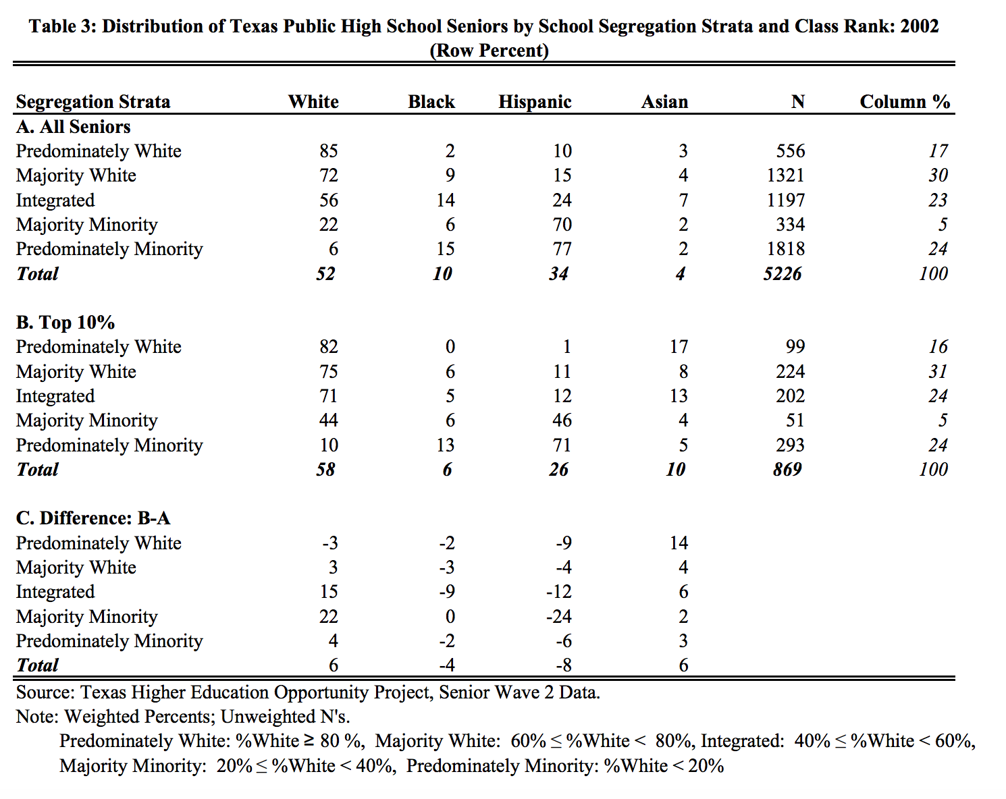

Along with racial segregation, Texas high schools are divided by socioeconomic factors. Academic studies investigating the effects of TTPP identified five economic strata in Texas high schools. These strata were identified by the percentage of students ever classified as economically disadvantaged and included the following categories: affluent (low shares of disadvantaged students), feeder (affluent schools with strong history of sending students to flagship schools), poor (high shares of disadvantaged students), Longhorn/Century (poor schools with low college-going history, these schools are targeted by flagships for outreach and scholarships), and typical (average shares of disadvantage students) (Niu & Tienda, 2010). Across these strata, there was some overlap in racial segregation, though it was found in the extremes. Typical high schools included predominantly white, integrated, and predominantly minority schools. Predominantly minority schools were represented in typical, poor, and Longhorn/Century schools, but none of the affluent or feeder schools were predominantly minority. White students were over represented in affluent and feeder schools (69-74% of the student populations) but had low representation at schools with large shares of disadvantaged students (20-25% of student populations) (Niu & Tienda, 2010).

**Opposing Views**

Like Affirmative Action, the TTPP is a highly controversial and divisive topic. Supporters of the plan primarily cite the drawbacks of other admission factors. There are many arguments that standardized tests such as the SAT and ACT have a racial and socioeconomic bias. These tests also test aptitude on a particular day, without accounting for external factors. A student’s GPA, on the other hand, is earned over a semester’s work. High school GPA has also been found to be a better predictor than standardized test scores for freshman year undergraduate GPA and overall four-year outcome in the University of California System (Geiser & Santelices, 2007).

Detractors of the plan cite multiple drawbacks, including concerns over autonomy (at both the high school and college level), segregation, and discrimination. Under TTPP, high schools have a large amount of autonomy in determining class rank, including the GPA weightings discussed above and the size of the top decile. The University of Texas at Austin argued that the law restricted its admissions autonomy and prevented it from admitting otherwise qualified students. In 2008, 81% of its incoming freshmen were admitted under the rule. In 2009, an amendment was included to cap the number of students admitted under the plan to 75% for UT only (Tribpedia: Top Ten Percent Rule). As discussed earlier in this paper, the TTPP owes its success to the highly segregated environment in which it takes place. There are concerns that the TTPP success will discourage attempts to resolve segregation and may encourage actions that would intensify the problem. As was seen with affirmative action, there are claims of discrimination inherent in the TTPP. In the next portion of this paper, the students negatively impacted by TTPP are identified. The demographics of that group are not surprising. What is surprising is the argument made by Cara Davis in the Southern University Law Review that given the cap on the UT’s TTPP admissions and the high segregation in the state, the terms of the plan are now an “unconstitutional quota in disguise” (Davis, 2013). Two different groups are looking at the same plan and finding very different forms of discrimination.

**Impact of TTPP**

A number of academic studies have been generated on the effects of the Top Ten Percent Plan. Below is a summary of some of the most note-worthy studies.

*Who did the TTPP most affect?*

Prior to the enactment of the Top Ten Percent Plan, a handful of affluent, largely suburban high schools sent large numbers of students to flagship universities while the majority of other Texas high schools did not send any students (Niu & Tienda, 2010). After the law went into effect, a discontinuity regression identifying the relationship between flagship enrollment and class rank was used to examine trends above and below the 10% cut off point. No discontinuity was found for all seniors, whites seniors, and Asian seniors. However, discontinuity in Hispanic senior enrollment was found. Similarly, enrollment decisions for students from typical high schools were discontinuous, though affluent, feeder, poor, and Longhorn/Century school enrollments were unaffected across class rankings. Finally, students from predominantly minority high schools (80% or more minority students) were shown to be affected by the 10% cut off. (Niu & Tienda, 2010). Figures from this study depicting the discontinuities as well as the overall trend are shown below (y axis is probability of enrollment in flagship schools): 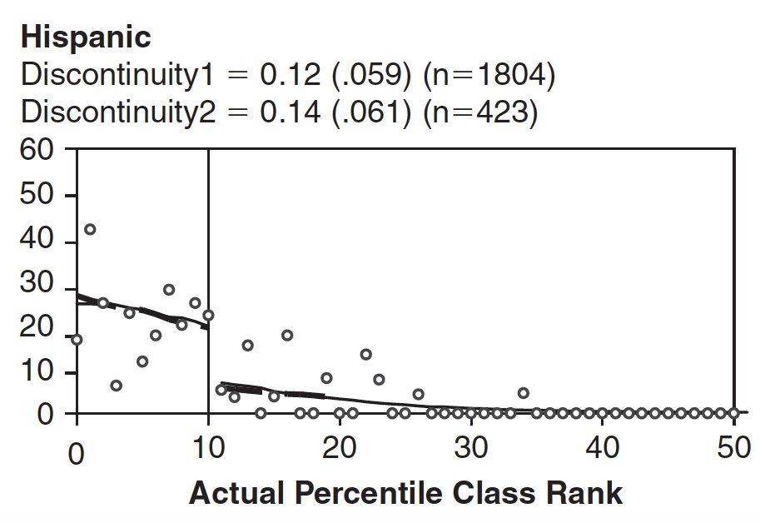

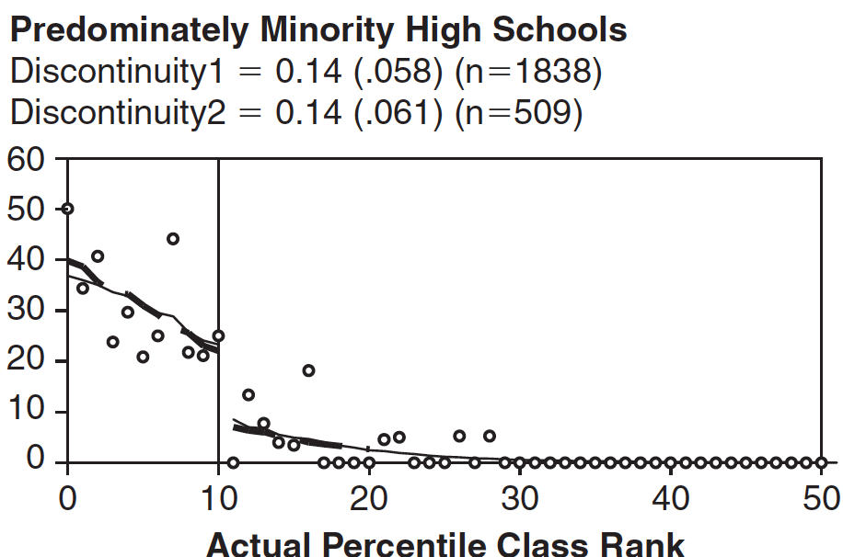

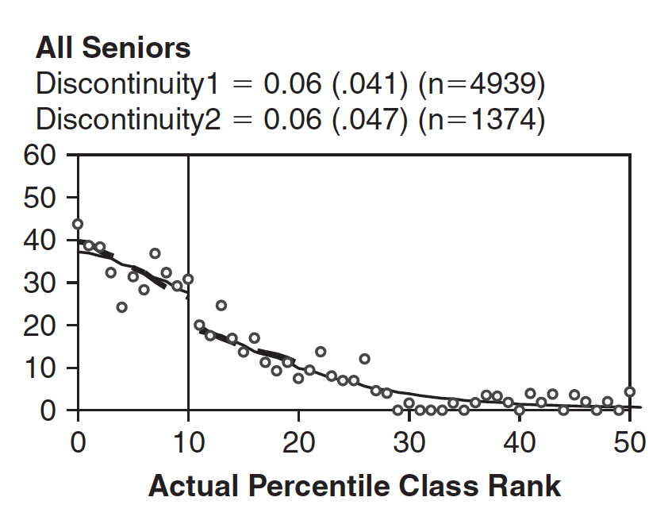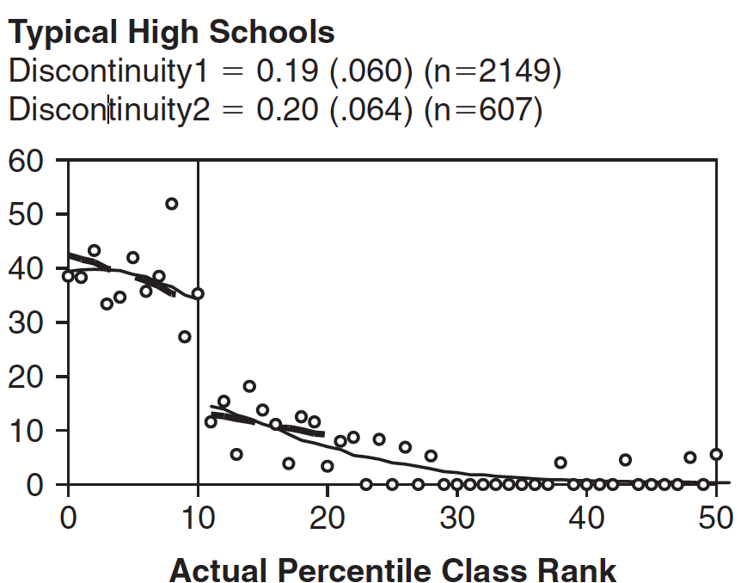 (Niu & Tienda, 2010)

Given that the total number admission slots at flagship schools are relatively fixed, admissions are a zero sum game. While probable and actual enrollment increased for some students, they decreased for others. The group of students most negatively affected by TTPP was those in the third decile of their high school class rankings (Niu & Tienda, 2010). The figure below shows enrollment by class rank of different high school types at the University of Texas at Austin between 1990 and 2003. Enrollment of the third decile or lower decreases across both race and high school economic strata; however, the largest decrease for this decile is in the feeder and affluent schools.

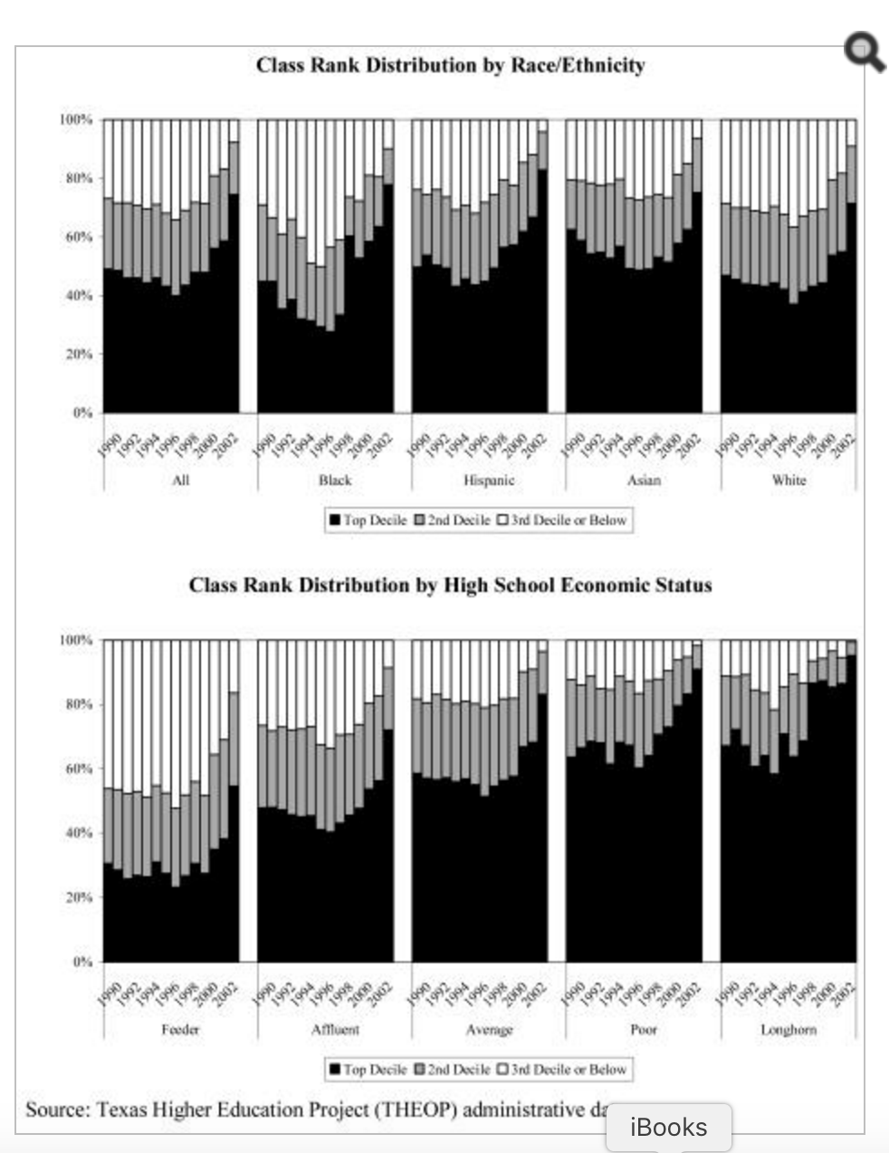

(Niu & Tienda, 2010)

*“Brain Drain” Fears*

Following the enactment of TTPP, concerns of a “brain drain” were raised. Brain drain, also known as human capital flight, normally refers to the migration of well-educated, capable individuals to seek out better conditions. As a result, the places of their origin suffer a “drain” of human capital. Demands for admission to flagships schools increased, since these schools were the most affected by TTPP. This increased demand and the scarcity of admission positions led to fears that the second deciles of highly competitive high schools were edged out. The assumption of these brain drain concerns is that these otherwise highly qualified students would leave Texas for post-secondary education in other states after being “squeezed out” of admission by students in the upper decile of non-competitive high schools.

Using the same economic strata as in the previous study, a new study examined the stated preferences and ultimate enrollment decisions of a representative sample of seniors across the economic strata of high schools with special attention paid to the placement of second decile students among flagship, two-year state schools, and out-of-state schools. The upper decile of feeder schools was more likely to both prefer and ultimately attend flagship schools when compared with their rank-equivalent at typical high schools. The first quintile of feeder schools had a higher stated preference than other seniors for out-of-state schools as both their first and second choice. The second decile of these schools were just as likely as the upper decile to have these preferences, so it is unlikely that they are contingent on perceptions about their chances of acceptance at an in-state flagship. Of second decile students at feeder schools who stated flagship schools as their top preference, 96% attend in the fall (seen in the figure below). It appears for students at these schools, their application credentials other than class rank are strong enough for admittance. This empirical evidence confirms that students at feeder schools have an advantage over other students and refutes the hypothesis of a brain drain in Texas (Tienda & Niu, Flagships, Feeders, and the Texas Top 10% Law: A Test of the "Brain Drain" Hypothesis, 2006).

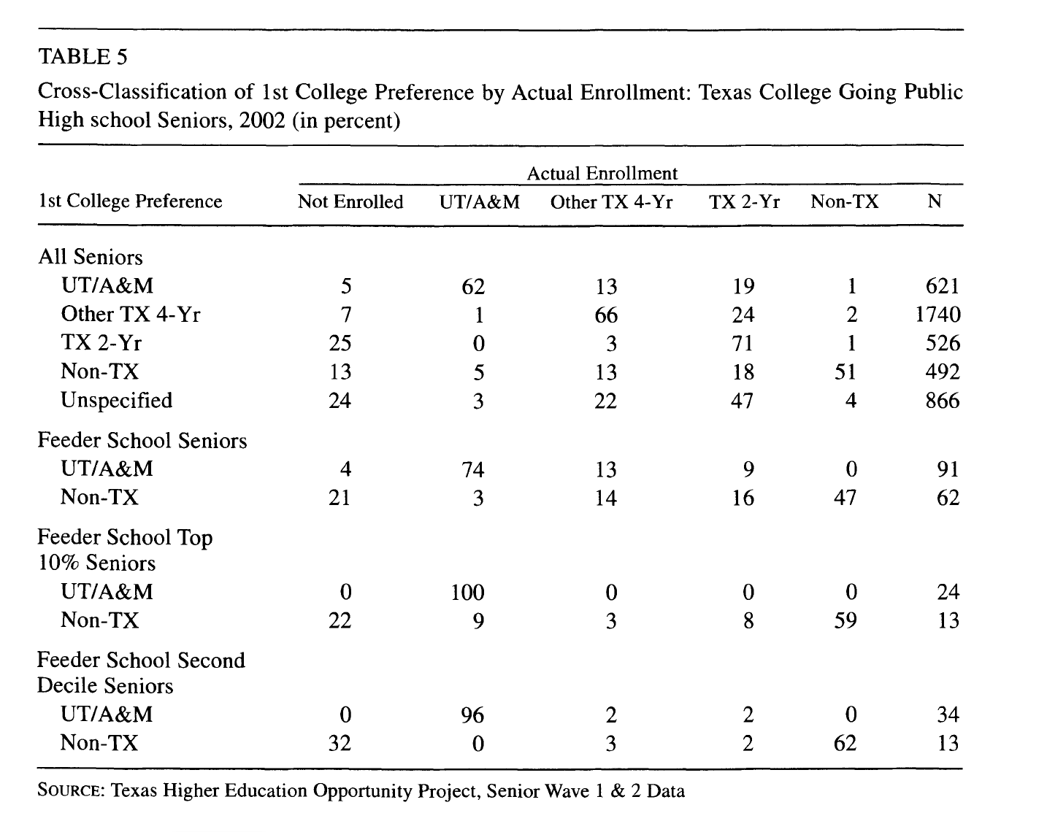

(Tienda & Niu, Flagships, Feeders, and the Texas Top 10% Law: A Test of the "Brain Drain" Hypothesis, 2006)

*Performance of Longhorn/Century Scholars and Affluent Students*

One of the criticisms of the TTPP is based on the mismatch theory. This theory suggests that students who are the beneficiaries of the affirmative action preference are placed in universities where they cannot be competitive and would instead thrive at less competitive schools (Sander & Taylor Jr., 2012). Critics of the TTPP (and other preference policies) argue that students who benefit from this plan are from lower resourced schools and are not well prepared for college study, while counterarguments have been made that students in the top decile of lower resourced schools should perform well partly due to a strong motivation to excel (Niu & Tienda, 2010). A study of Longhorn and Century high school students between 1990 and 2003 examines these claims. This study compared the academic performance of the top decile students at Longhorn and Century high schools with the performance of students that were most likely to be displaced by the TTPP, the third decile or below at affluent and feeder schools.

In comparing the college performance of top decile students at Longhorn/Century high schools with those from affluent/feeder schools who were not in the top decile but had higher test scores, Longhorn/Century students performed as well as or better than the other students. The figure below shows the academic performance of both groups across multiple measures:

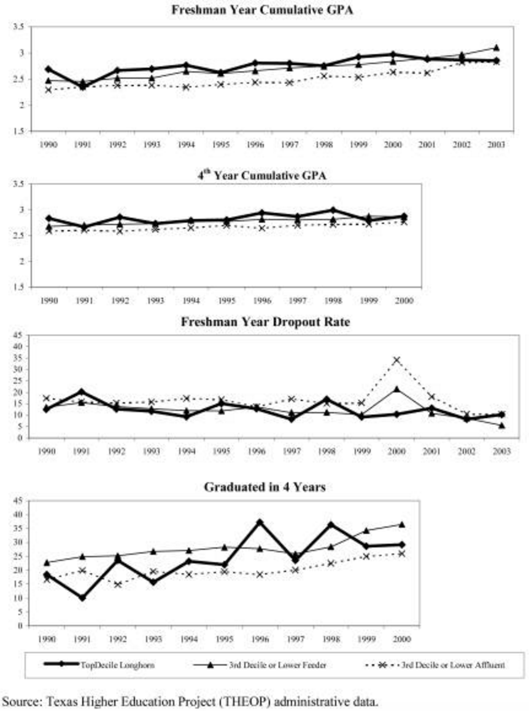

(Niu & Tienda, 2010)

These findings are for a very small subset of total admitted students. These students are targeted by flagship outreach programs and are provided support not available to applicants from other schools. A broader study might provide more empirical evidence to dispute the mismatch theory claim.

*Perverse Incentives*

With any new policy, there is the risk of generating perverse incentives. While the TTPP was intended to increase diversity at state universities, there are concerns that, because it is implemented and successful in an environment steeped in school segregation that underrepresented minorities have a perverse incentive to maintain or increase these levels of segregation. In a study examining the strategic movement of second decile students between schools, it was found black and Hispanics had a lower probability of being in the top decile at integrated and majority white schools than in majority minority or predominantly minority schools (Cullen, Long, & Reback, 2013). It was found that black and Hispanic students had more opportunity and motive than white students to strategically move from a competitive high school to a lower-resourced school. However, regardless of the race of the student making this strategic decision, the students negatively affected by this perverse incentive were almost always underrepresented minorities. The table below displays the percentage of the sample with opportunities and motive along with the take up rates for that subset.

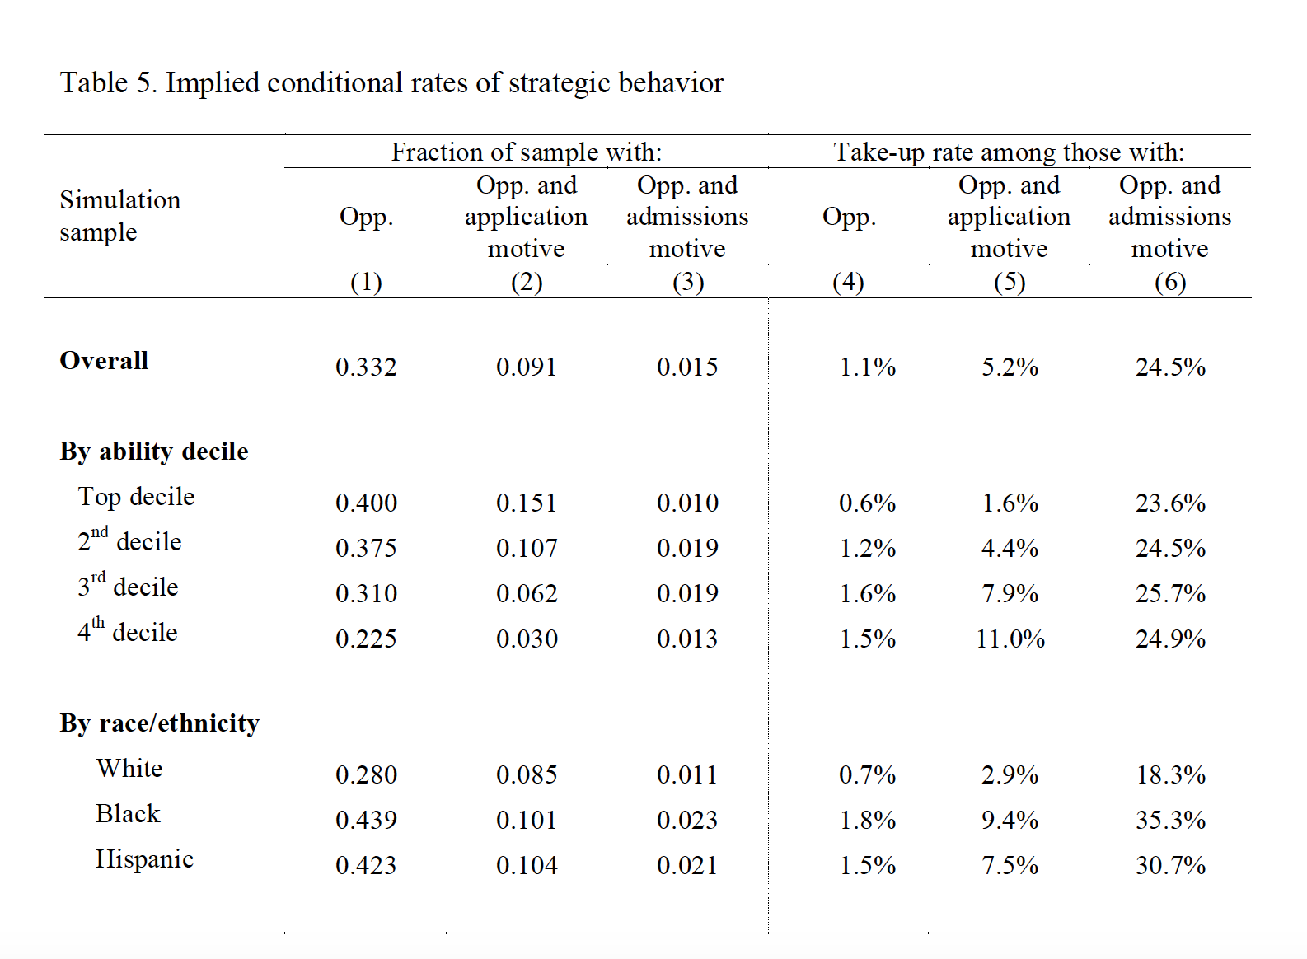

(Cullen, Long, & Reback, 2013)

***Fisher v. University of Texas***

On December 9th, 2015, the Supreme Court heard arguments in *Fisher v. University of Texas*. This case concerns the use of race in admissions for students outside of the top decile of their high school, but could have implications for the TTPP as well. When the case was first heard in 2013, the majority decisions upheld the state’s compelling interest in diversity but emphasized again the need for narrow tailoring, specifically stating that there is an obligation of schools to document “whether a university could achieve sufficient diversity without using racial classifications” (Fisher v. University of Texas at Austin, 2013).

Justice Scalia recently created controversy when regarding black students with a science major preference he stated, "They come from lesser schools where they do not feel that they're - that they're being pushed ahead in - in classes that are too - too fast for them," (Barnes, 2015). These statements echo the sentiment of the mismatch theory. Scalia made these comments specifically about a specific race of students, however he does not make it clear whether these students were accepted through the TTPP or the affirmative action policies for students outside of the top decile. Given that these are not the same type of students, criticism about their aptitude should not be broadly given.

It is possible the case could result in a 4-4 slit; Justice Kagan has recused herself, given her prior involvement with the issue as former solicitor general. A tie would result in an affirmation of the lower court’s ruling in UT’s favor but would set no precedent for future cases and likely be an unsatisfying outcome (Barnes, 2015).

**Final Thoughts**

Given the extensive history of inequality in America generally and Texas specifically, and the compounding effects of inequality, providing quality education and opportunity to a historically disadvantaged subset of the population is a laudable desire of these institutions. However, there is no simple solution to a deeply rooted problem. Given the context in which TTPP was made, it seems reasonable and on its face, even merit-based. However TTPP does not exist in vacuum, but in an inherently unequal environment.

This is admittedly a very broad subject with many factors and implications. While there has been extensive research on which groups are most affected by TTPP and in what way, there is little study into how the world external to these universities have responded. A study examining the career opportunities and tracks of students most affected by TTPP would be recommended. Policy research on alternative admission criteria (including an index of GPA, test scores, and essays) would be prudent, especially if the Supreme Court ruling results in a condemning of affirmative action.

# Works Cited

Andrews, R. J., Li, J., & Lovenheim, M. F. (2012). Quantile Treatment Effects of College Quality on Earnings: Evidence from Administrative Data in Texas. *NBER Working Paper* (18068).

Arcidiacono, P. (2005). AFFIRMATIVE ACTION IN HIGHER EDUCATION: HOW DOADMISSION AND FINANCIAL AID RULESAFFECT FUTURE EARNINGS? *Econometrica - Journal of The Econometric Society* *, 73* (5), 1477–1524.

Backes, B. (2012). Do Affirmative Action Bans Lower Minority College Enrollment and Attainment? Evidence from Statewide Bans. *The Journal of Human Resources* *, 47* (2), 435-455.

Barnes, R. (2015, Dec 5). Affirmative action case returns to a divided court. *Chicago Tribune* .

*Center for Health Statistics - Census 2010*. (n.d.). Retrieved from Texas Department of State Health Services: https://www.dshs.state.tx.us/chs/popdat/Census2010.shtm

Cullen, J. B., Long, M. C., & Reback, R. (2013). JOCKEYING FOR POSITION: STRATEGIC HIGH SCHOOL CHOICE UNDER TEXAS’ TOP TEN PERCENT PLAN. *Journal of Public Economics* *, 97*, 32-48.

Dale, S., & Krueger, A. B. (2011). ESTIMATING THE RETURN TO COLLEGE SELECTIVITY OVER THE CAREER USING ADMINISTRATIVE EARNINGS DATA. *NBER Working Paper Series* (17159).

Davis, C. (2013). A WOLF IN SHEEP'S CLOTHING: HOW TEXAS'S TOP TEN PERCENT LAW IS THE UNCONSTITUTIONAL USE OF RACE AND A RACIAL QUOTA IN DISGUISE. *Souther University Law Review* *, 40* (2).

Fisher v. University of Texas at Austin, 570 U.S. (Supreme Court 2013).

Flores, S., & Horn, C. L. (2015). *Texas Top Ten Percent Plan: How It Works, What Are Its Limits, and Recommendations to Consider.* NYC: Educational Testing Service.

Furstenberg, E. (2010). Academic Outcomes and Texas's Top Ten Percent Law. *The Annals of the American Academy of Political and Social Science* *, 627*, 167-183.

Geiser, S., & Santelices, M. V. (2007). VALIDITY OF HIGH-SCHOOL GRADES IN PREDICTING STUDENT SUCCESS BEYOND THE FRESHMAN YEAR: High-School Record vs. Standardized Tests as Indicators of Four-Year College Outcomes*. *Research & Occasional Paper Series* *, 9*, 1-35.

Gratz v. Bollinger, 539 U.S. 244 (Supreme Court 2003).

Grutter v. Bollinger, 539 U.S. 306 (Supreme Court 2003).

Hinrichs, P. (2012). THE EFFECTS OF AFFIRMATIVE ACTION BANS ON COLLEGE ENROLLMENT, EDUCATIONAL ATTAINMENT, AND THE DEMOGRAPHIC COMPOSITION OF UNIVERSITIES. *The Review of Economics and Statistics* *, 94* (3), 712-722.

Hoekstra, M. (2009). THE EFFECT OF ATTENDING THE FLAGSHIP STATE UNIVERSITY ON EARNINGS: A DISCONTINUITY-BASED APPROACH. *The Review of Economics and Statistics* *, 91* (4), 717-724.

Hopwood v. University of Texas , 78 F.3d 932 (5th Cir. 1996).

Leicht, K. T., & Sullivan, T. A. (2000, May 25). *Minority Student Pipelines Before and After the Challenges to Affirmative Action.* Retrieved Nov 10, 2015, from Texas Higher Opportunity Project: http://theop.princeton.edu/

Long, M. C. (2007). Affirmative Action and Its Alternatives in Public Universities: What Do We Know? *Public Administration Review* *, 67* (2), 315-330.

Niu , S., & Tienda, M. (2010). The Impact of the Texas Top 10 Percent Law on College Enrollment: A Regression Discontinuity Approach. *Journal of Policy Analysis and Management* *, 29* (1), 84-110.

Niu, S. X., & Tienda, M. (2010). Minority Student Academic Performance under the Uniform Admission Law: Evidence from the University of Texas at Austin. *Educ Eval Policy Anal* , 44-69.

Regents of the University of California v. Bakke, 438 U.S. 265 (Supreme Court 1978).

Sander, R., & Taylor Jr., S. (2012). The Painful Truth About Affirmative Action. *The Atlantic* .

Tienda, M., & Niu, S. X. (2006). Capitalizing on Segregation, Pretending Neutrality: College Admissions and the Texas Top 10% Law. *American Law and Economics Review* *, 8* (2), 312-346.

Tienda, M., & Niu, S. X. (2006). Flagships, Feeders, and the Texas Top 10% Law: A Test of the "Brain Drain" Hypothesis. *The Journal of Higher Education , 77* (4), 712-739.

*Tribpedia: Top Ten Percent Rule*. (n.d.). Retrieved from Texas Tribune: https://www.texastribune.org/tribpedia/top-ten-percent-rule/about/